**Jupyter Notebook (to-remember)**

**Commands:**

**Print** – print ()

**Input** – Input (“”)

**Concatenation** – string + string

Note = string is a data type which can be text, number, or symbol (anything). It can be joined to other strings but a string that is a number cannot be used for calculations.

Error 🡪 Nonetype – undefined data type.

Boolean – True/false (only two formats)

Define a variable that can store the value.

* A variable can have any name.



Execute the previous cells for the future ones to work.



Two way to print and see an output.

* X
* Print (x)

If it is just about giving the numbers and no instructions then there won't be any need for strings to be in commas however, if you are trying to describe the work you are doing then the string should be in commas and the rest can just go normal.

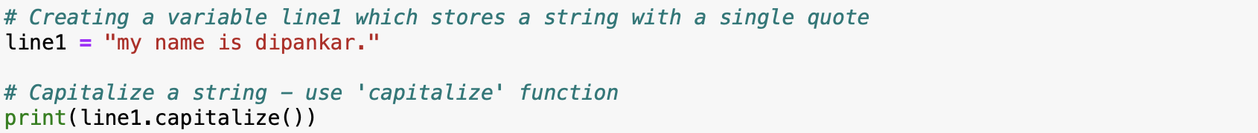

First, you have to define the value and then call the function followed by a dot

() – helps pass the argument that needs to be printed, if not, then it can be left blank.

Control structures – “if”

Indentation is the main key for Python – indented block error.